CHAPTER ONE

I. Introduction

- 1 Background of the Study

Today's companies are facing toughest competition than ever. Companies can win the completion by doing a better job in order to satisfy the customer needs, wants and customer centred companies are adopt at building customers, not just building a product.( Johansson J.K 2000:12)
Customer satisfaction is a person telling of pleasure or disappointment resulting from comparing a product perceived performance in relation to his or her expectation. (Kotler 1999:7)
As it is made clear from the above definition customer satisfaction is a function of perceived performance and expectation, the customer is satisfied. If the performance falls short of expectation the customer is dissatisfied. If the performance matches the expectations, the customer is highly satisfied or delighted.

It has become increasingly evident that a successful marketer must start with the customer. Marketing opportunities are based on identification of customer wants and needs, an understanding of how customers make buying decision, how the use the goods and service they buy, and their level of commitment to current brands. (Anderson) Vincze, 2000:85)
The major purpose of a business is to make profit by selling the product or services of the company. To do so the company should have effective activity in selling activities and creating motivated sales people by using different methods.

Marketing managers must think the methods of winning retailing in general, satisfying customers from various ways which will lead to organizational success. To do so, the elements of marketing mix (price, product, promotion and place) and selling function serve as the most crucial tools for meeting the company's objective together with satisfying customers through effective utilization of them.

It is through the effective implementation of the marketing activities and effective selling activity the overall company objective.

Therefore undertaking such study helps the company to calculate its pricing. Sells and distribution system and to design better strategy such issues to satisfy the customers as the same time increase the market share of the company.

1. 2 Statement of the Problem
There are many factors that influence the company in price decision like, marketing objectives, marketing mix strategy and costs as internal marketing factors and the marketing and demands as external factors.
There are also approaches used by the company to set price. After setting a price sometimes the company may obligate to adjust the price. So, regarding price the paper is focus on how the pricing decision factors influence the company, what pricing approach did the company has been used and the situations to adjust the price.
The channel members play many specialized roles such as, information, promotion, contact, matching and negotiation. A company might use direct channel or indirect market channels. The direct one is without the use of intermediary. The indirect marketing channel uses one or more intermediary levels. To decide channel design, the company should first analyze consumer service needs, setting the channel, objectives and constraints, identifying the major channel alternatives and evaluating them. So, this research paper tried to assess the specialized roles that the company's channel members play and the way the company use to make channel designing decision.
The sequence of activities that guides managers in the creation and administration of sales programs for a firm is known as the sales management process. First, the firm must come up with a selling strategies and a plan of action. Then sales management has to locate target customers and recruit, train, motivate, compensate and organize a field sales force. The next phase of the process is concerned with the interactions between customers and salespeople. The result of successful sales person or customer reaction are orders, profits, repeat customers and after sale service. The last phase of the process focuses on evaluation of the field sales force and the feedback of suggestions to senior managers so that they can modify plans for future.
Personal selling has more importance than that of other forms of promotion. Like, there is a direct contact between buyers and salesperson. So that regarding sales this paper tried to consider whether the company uses personal selling or not and how the firm runs its sales management process.
When managers don't follow a defined sales management process, chaos reigns and field reps merely react to customer requests rather than help them solve problem.

1.3 Objectives of the Study
1.3.1 General objective
The major objective for all of business organization is to make profit by winning the interest of customers by making them satisfied. To do this in a good way, business organization must use marketing mix like pricing and distribution. When they practice these marketing mixes they must consider about economic, cultural, socials and legal aspects of the business environment. Therefore, the general objective of this research paper as concerned to
- Evaluate the pricing approach and distribution system of the concerned company.
- Evaluating sales activity of the company was the objective of the study.

1.3.2 Specific objectives
If the company uses the sales management process, the study was based on measuring the effectiveness of firm's sales management process. The research paper also needs to indicate the value of personal selling to the company. This paper also strive to identify the specialized roles that are performed by channel members and asses the pricing decision factor that influence the company and approaches used to set price.

1.4 Significance of the Study
There are fifteen competitors of Guna in the distribution of construction materials. One of the way that companies considered as winner is having high market share, so in this paper there are some possible actions to be suggested for the company to increase its market share. The study aimed to identify the company's strengths and weakness concerning pricing, sales and distribution system and help to take corrective action regarding its weakness.

1.5 Scope of the Study

Guna trading is involved in the export market of oil seed and coffee, in addition to this the company imports and distributes Reinforcement bar, Angle iron, Sheet metal, Timber, Building glass etc. The study focused on local market especially in Addis Ababa regarding construction materials.

1.6 Methodology of the Study
To conduct this research both primary and secondary data are tried to collect by using:-
- Primary data collection
As a primary data collection interview and questionnaire are found to be appropriated. This research is conducted on the basis of sampling. From the sampling techniques, simple random sampling method been used from the total permanent customers of the company. 80 % of customers are corporate or organizational customers. The total number of these customers is 34 and 18 of them been taken as a sample to fill questionnaire. And interview had been conducted the concerned person in the organization, that is sales division manager.
- Secondary data collection
With this regard, as information obtained from the organization are highly reliable it is obvious it would have a great implication for the study to use records which are kept in the organization.
Records may include
- Annual sales or marketing report
- Organizational marketing manuals
- Other research studies
- Any published and non published materials

1.7 Data Analysis Method
After the data has been gathered, the information is edited, tabulated and interpreted or analyzed using percentage and numerical values. The data that obtained from interview and secondary sources also presented in the statement form and graph. Finally possible conclusions are drown and recommendation have been given based on the data being analyzed.
1.8 Organization of the Study
The study is organized by balancing the scope and depth of the study as well as the following coherent steps. Thus, the papers have four chapters which are sequentially arranged. Chapter one is introduction, chapter two deals with review of related literature which is systematically organized from different books, chapter three is about presentation and analysis of the collected data and finally chapter four has present the conclusion and recommendation. The research paper also has references and annex section.

CHAPTER TWO
II. Literature Review
2.1 Pricing
2.1.1. Definition of price
Price is the amount of money charged for a product or service, or the sum of the values that consumers exchange for the benefits of having or using the product or service.
2.1.2. Factors to consider when setting prices
A company's pricing decisions are affected by both internal company factors and external environmental factors.
Internal factors affecting pricing decisions:-
Marketing objective: the company may seek additional general or specific objectives. General objectives include survival, current profit maximization, market share leadership and product quality leadership. At a more specific level a company can set price low to prevent competition from entering the market or set price at competitive level to stabilize the market.
Marketing mix strategy: price is only one of the marketing mix tools that accompany use to achieve its marketing objectives. Decisions made for other marketing mix variables may affect pricing decisions.
Costs: the company wants to charge a price that both cover all its cost for producing, distributing and selling the product and deliver a fair rate of return for its effort and risk. Companies with lower costs can see lower price that results in greater sales and profits.
Philip Kotler Principles of Marketing, Page 309-312

Organizational consideration: - management must decide who within the organization should set prices. Companies handle pricing in a variety as ways. In small companies, prices are often set by top managements rather than by its marketing or sales department. In large companies pricing is typically handled by divisional or product line managers.
External Factors Affecting Pricing Decisions
External factors that affect pricing decision - include the nature of the market and demand, competition and other environmental elements.
Philip Kotler Principles of Marketing, Page 307, 315
2.1.3 General Pricing Approaches
Product cost set a price floor to the price, consumer perception of the product value set the selling between those two extremes the company must consider. Competitor price and other external and internal factors to find the best price,
Companies set price by selecting a general pricing approach that includes one or more of these three sets of factors. These are:-
- Cost Based Pricing
The simplest pricing method is cost - plus pricing adding a standard mark up to the cost of the product. Break even analysis and target profit pricing is setting price to break even on the cost of marking and marketing a product or setting price to make a target profit.
- Value Based Pricing
Value - based pricing uses buyers' perceptions of value, not the sellers cost, as the key to pricing. Value based pricing means that the marketer can't design a product and marketing program and then set the price.
- Competition based pricing
Setting price based on the prices that competitors charge for similar products.

2.2 Sales
2.2.1 Definition of Sales Management
Sales management originally referred exclusively to the direction of sales force personnel. Latter the term took broader significance in addition to the management of personal selling ''sales management'' meant management of all marketing activities including advertisement, sales promotion, marketing research physical distribution, pricing and product merchandising.
The definitions committee of the American Marketing Association agreed that sales management meant ''the planning, direction and control of personal selling and motivating as these tasks apply to the personal sales force''
'' Still Cundiff Govoni ''Sales Management 5th Edition. Page 3

2.2.2 Sales Management Process
2.2.2.1. Developing the selling function
Personal selling is critical to the movement of many goods and services and can be defined as direct communication between paid representatives and prospects. Personal selling has different advantages over other forms of promotion.
Where advertisement and sales promotion ''pull'' merchandise through the channel, personal selling provides the ''push'' needed to get orders signed. Also with public relations, the message is perceived as coming from media rather than directly from the organization. Personal selling involves two -way communication with prospects that allows the sales message to be adopted to the special needs of the customer. It is more effective than other modes of promotion in classing sales.

Dauglas J. DALRYMPLE William L.CRON. Sales management 4th edition

2.2.2.2. Strategic Sales Planning
A Sales management on the administration of the personal selling function in the marketing mix. This administration role includes the planning management and control of sales programs as well as the recruiting training compensating motivating and evaluating of field sales personnel.
A sale planning is made easier when managers have good data on where potential customers are located and how much they can be expected to buy - sales managers also need to be able to project sales for existing accounts and territories.
Sales management 4th Edition Dauglas J. DALRYMPLE William L.CRON.

A. Estimating potentials:-Market potential is an estimate of maximum demand in time period based on the number of potential users and the purchase rate. It is the maximum amount a firm can sell in a time period under optimum conditions.
All estimates of potential are based on two key components namely the number of possible users of the product and the maximum expected purchase rate.
Geographical potential can be quite helpful in making decisions on the allocation of sales people. Managers who know where potential customers are located can do a better job of designing sales territories and scheduling promotions to hit target market. Geographical potentials are particularly useful in decision on whether to expand into new foreign or domestic market.
DALRYMPLE CRON Sales management 4th edition. Page 306 - 308
B. Methods of Estimating Potentials
- Chain Ratio Method
A firm might start with population figures for relevant geographical areas and they multiply by ratios that discard non using segment of the market.
- Buying Power Index Method (BPI)
This index combines estimates of population, income and retail sales to give a composite indicator of customer demand in specific area.
- SIC Method for Business Market
The first step in estimating potentials from census data is to identify all the SIC Codes that make use of the product or service. This is usually accomplished by industries that are likely customers using judgement to pick likely codes from the SIC manual and running surveys of different types of firms to see where products are employed. Next the firm must select an appropriate data base for estimating the amount of the product that will be used by SIC code.
- Scrap age Method
Estimating market potential for durable goods often depends on the rate owners scrap products due to wearing out or obsolescence. The scrap age method is most useful for mature products where replacement demand is important. This method doesn't work for new items where customers are still being introduced to the product.
Dauglas J. DALRYMPLE William L.CRON. Sales management 4th edition Page 309-314

2.2.2.3. Building a sales program
To implement a sales strategy, all of the employees of an organization must have a marketing focus and an interest in filling customer needs. Sales managers are often responsible for making sure that employees outside the sales organization share the enthusiasm needed to make the sales plan succeed. They must also make sure the firm heirs enough sales people with the appropriate skills and backgrounds to implement the sales strategy.
After sales people have been hired, they must be trained before they are sent into the field. Sales managers are responsible for making sure sales training is completed and they often conduct some of the classes.
Most training is designed to familiarize sales people with the company's product, services and operating procedures, with more limited time devoted to development of selling skills.
Dauglas J. DALRYMPLE William L.CRON. Sales management 4th edition Page 9

2.2.2.3.1. Why train sales people?
- Reduced Turn Over
Sales people who go into the field without adequate training typically find it difficult to see buyers, answer questions, or book orders. The resulting confusion and disappointment often lead novices to quit before they have a chance to learn how to sell effectively.
- Improved Customer Relation
Industrial buyers, in particular, complain that too much of their time is wasted in dealing with untrained sales people. Buyers don't like to spend their days counselling sales people on market conditions and product needs. They prefer to work with trained sales people with a thorough knowledge of the industry, their firm's business and their own product lines. Such sales people then become consultants and problem solvers.
- Better Morale
Sales training increases product knowledge and improves selling skills; it also builds self-confidence and enthusiasm among the sales force. When sales people know what they are supposed to do, they are in a better position to withstand the disappointments and meet the challenges of a sales career. Trained sales people start producing orders faster and the increased earnings help boost morale.
- Control
Another benefit accruing from a company owned sales training program is that of control over sales people treatment of customers.
- Increased Sales
The ultimate objective of any training program is to increase profitable sales.
Dauglas J. DALRYMPLE William L.CRON. Sales management 4th edition Page 438-440

2.2.2.4. Assign sales people to individual territories
Based on the forecasts of the sales potential for each customer and market area customers can be grouped together to form territories that minimize travel and contract costs. The proper design of sales territories helps the sales department to provide optimum customer services and satisfaction at an acceptable cost. A territory is those customers located in a geographic area that are assigned to an individual salesperson.
Why use territories?
The primary benefit from using sales territories is improved market coverage which usually means better customer relations. Having each field representative assigned to a specific group of customers and prospects enables the sales person to know each customer's needs, which, intern leads to improved service on orders and delivery. Many customers prefer building an enduring relationship with a single field rep rather than having to get acquainted with a mew person on each call.
The use of territories also benefits sales people. When sales people know that all the customers in an area are their responsibility, sales people are more likely to put forth extra effort to satisfy customer demands. The performance of individual sales people can be more easily controlled with sales territories.
When are territories unnecessary?
Company that sell directly to consumers don't have assigned territory.
Dauglas J. DALRYMPLE William L.CRON. Sales management 4th edition Page 483-486
2.2.2.5 Controlling the sales force
Effective sales managers know how to supervise and keep track of what their reps are doing. Sales managers use a variety of tools in their efforts to motivate sales people to work more efficiently and effectively.
The most powerful motivator for salespeople is a well designed compensation package. Thus it is a key task for sales managers to come up with an effective mix of salary, bonuses, commissions, expenses and benefit without putting the firm's profitability in jeopardy. Sales managers also provide leadership to inspire their people to grow and develop professionally and achieve the revenue goals of the firm.
The next step in the sales management process is to evaluate the overall performance of the sales force. This involves analyzing sales data by region, product, channel, and customer breakdown. It also means reviewing selling costs and measuring the impact of sales force activities on profits.
The sales manager final task is to evaluate the performance of individual sales people. The first job is to identify an appropriate set of control factors. These are usually divided into behavioural or input factors such as number of calls, report prepared and displays erected; output measures include sales per order sales growth and number of new accounts.
A sale force evaluation often suggests often suggests adjustments and changes for the sales program. This feedback is used to modify both the selling strategies of the firm and the organization and training of the sales force.

2.2.3 Sales force organization principles
Specialization: - With the exception of start up business or very small organizations, some degree of specializations is included in the organization of most sales force. Sales forces are usually organized around geographic areas, customer, product or functional specialization with the use of geographic territories.
The basic motivation behind sales force specialization is to increase productivity by encouraging sales people to become experts on certain tasks, products and or customers.
Tele marketing: - An increasingly popular method for achieving improved sales results in with telemarketing support system. Tele marketing refers to customers contacts utilizing telecommunications technology for personal selling without face- to -face contact.
National accounts: -It may take a variety of forms, but is essentially an effort to provide the kind of services and products necessary to sell and establish a long term relationships with a firms key customers. These programs are sometimes referred to as key or major account programs one reason organizations are initiating national account programs is the concentration of their revenues among a few very important customer .
A second reason for the growth of national account programs is that customers are looking for sale -supplier relationship as a way to reduce costs and increase productivity and quality.
Independent sales agents: - An important strategic alternative is to hire independent sales selling function. Sales agents are not employees, but are independent business given exclusive contracts to perform the selling function within specified geographic areas.
Agents are likely to be used to develop new markets through a combination of persuasive selling skills and technical competence.
Dauglas J. DALRYMPLE William L.CRON. Sales management 4th edition 356 - 367
    - The Sales Budget
Budgets a key element used by sales managers in planning programs to reach their objectives. A sales budget is essentially a set of planned expenses that is prepared on an annual basis.
2.2.4.1. The Sales Budgeting Process
- Design marketing program
- Set adv. An and promotion expenditure levels
- Forecast sales
- Estimate personal selling costs needed for each sales goals.
- Compare actual expenditures with plans.
- Revise expenditure categories.
- Request additional funds as needed
  - Distribution
2.3.1 Definition
Marketing channel or distribution channel: - is a set of interdependent organizations involved in the process of making a product or service available for use or consumption by the consumer or business user.
A company channel decision directly affects every other marketing decision but companies often pay too little attention to their distribution channels. In addition to this distribution channel decisions often involve longer commitments to other firms. Therefore management must design its channel carefully, with an eye anon tomorrow's likely willing environment as well as today's.
2.3.2 How Channel Members Add Value?
The use of intermediaries results from the greater efficiency in making goods available to target markets. Through their contacts, experience, specialization and scale of operation intermediaries usually often the firm more than it can achieve on its own.
From economic systems point of view, the role of marketing intermediaries is to transform the assortment of products made by producers into the assortments wanted by consumer. Producers make narrow assortments of products in large quantities, but consumers want broad assortments of products in small quantities. In the marketing channels intermediaries buy large quantities from many producers and break them down into the smaller quantities and broader assortments wanted by consumers. Thus intermediaries play an important role in matching supply and demand.
In making a product and service available to consumers, channel members add value by bridging the major time, place and possession gaps that separate goods and services from those who would use them.
2.3.3. Key function of channel members
Information - gathering and distributing marketing research and intelligence information about action and forces in the marketing environment needed for planning and aiding exchange.
Promotion - developing and spreading persuasive communications about an offer.
Contact - finding and communicating with prospective buyers.
Matching - shaping and fitting the offer to the buyer's needs including activities such as manufacturing, grading assembling and packaging.
Negotiation - Reaching an agreement on price and other terms of the offer so that ownership or possession can be transferred.

    - Number of Channel Levels
Companies can design their distribution channels to make products and services available to customers in different ways. Each layer of marketing intermediaries that perform some work in bringing the product and its ownership closer to the final buyer is a channel level. Because the producer and the final consumer both perform same work, they are part of every channel.
The number of intermediary level indicates the length of a channel. Direct marketing channel has no intermediary levels, the company sells directly to consumers. Indirect marketing channels are a channel containing one or more intermediary level.
    - Channel Design Decisions
Channel analysis and decision making should be more purposeful. Designing a channel system cause for analyzing consumer needs, setting channel objectives, identifying major channel alternatives, and evaluating them.
- Analyzing consumer needs: - Designing the marketing channel starts with finding out what target consumers want from the channel. The faster the delivery, the greater the assortment provided, and the more add- on services supplied, the greater the channel service level.
Providing the fastest delivery, greatest assortment and most services may not be possible or practical. The company and its channel members may not have the resource or skills needed to provide all the desired services. Furthermore, providing higher level of service, results in higher costs for the channel and higher price for consumers. The company must balance consumer needs not only against the feasibility and cost of meeting these needs but also against customer price preference. The success of discount retailing shows that consumers will often accept lower service level in exchange for lower prices.
- Setting Channel Objectives: - Companies should state their marketing channel objectives in terms of targeted levels of customer service. Usually a company can identify several segments wanting different level of services. The company should decide which segments to serve and the best channels to use in each case. In each segment, the company wants to minimize the total channel cost of meeting customer service requirements.
The companies channel objectives are also influenced by the nature of the company, its products, its marketing intermediaries, its competitors and the environment.
C. Identifying Major Alternatives: - When the company has defined its channel objectives, it should next identify its major channel alternatives in terms of types of intermediaries, the number of intermediaries and the responsibilities of each channel member.
D. Evaluating the Major Alternatives: - Suppose a company has identified several channel alternatives and wants to select the one that will best satisfy its long-run objectives. Each alternatives should be evaluated against economic, control and adaptive critical.
Using economic criteria, a company compares the likely sales, cost and profitability of different channel alternatives.
Principle of Marketing Philip Kotler, Gary Armstrong. Page 361-37
CHAPTER THREE
3. Data Presentation and Analysis
3.1. Background of Guna Trading House P.L.C.
Guna Trading House P.L.C. is a private limited company established according to the Ethiopian Commercial Code 51 of in 1992 G.C.
The company is legally registered as "GUNA TRADING HOUSE PRIVATE LIMITED COMPANY" and its trade mark is protected in the Ethiopian Patent Authority, certificate no. 4653 with paid up capital of USD 100 million.
Its registered head quarter is at Gerji backside Jackros Real Estate, Bole sub city, kebele 14/15 P.O.Box 80316, Addis Ababa.
Vision
"Globally competitive house of products and services with a billion dollar turnover by 2020".
Mission statement
"To be one of the leading import- export trading companies by satisfying customers 'and stake holders' needs so as to boost Owner's equity".
Core Values of the Company:-
- Learning organization
- Quality service to customers and stake holders
- Passionately owning the vision of the company by managers and employees at all levels
- Ethics of high standards as a Milestone.
Competitive advantages
- Recognize trusted brands that deliver our customers' expectations
- The company makes best use of information and communication technology.
- Equipped with high standard ware houses
- Application of quality management system (QMS), Quality circle and other relevant transformational schemes
- Equipped with state - of - the - art of sesame cleaning machine
- Exploiting the synergy opportunities of all sister companies
- Availability of proficient and experienced manpower
Business objectives
- To be prominent for its reliable service delivery to its customers.
- To build capable workforce of the required competence by introducing capacity development programs.
- To play a leading role in the country's foreign trade.
- To be one of the main distributors of agricultural and industrial inputs.
- To contribute to the development of an honest and genuine trade industry in the country.
- To maximize wealth by participating mainly on business lines that contributes to the growth of the nation's economy.

Major business activities of the company
The company is mainly engaged in importing industrial products such as reinforcement bar, timer, bitumen, tyre, chemical, glass etc and distributing locally produced goods such as cement, glass, garment, and textile products among others. It exports agricultural products primarily sesame, Gum Arabic, Gum olibanum, coffee, pulses, spices, etc.
On top of this, it offers commission service as agent of internationally renowned companies.
Guna is prominent for its reliable service and product delivery to its customers and overall performance in the trading industry.
Guna Trading House PLC offers a wide range of quality products and services with special emphasis on good values to clients around the world.
3.2. Data presentation and analysis
This chapter is concerned with data presentation which is collected through interview and questionnaires, and analysis and interpretation 18 questionnaires have been prepared and distributed to Guna Trading House PLC customers. (Refer the attached questionnaire i.e. annex I). The information also obtained through interview question conducted with the marketing manager of Guan. (Refer the attached interview questions. i.e. annex II)
3.2.1. Questionnaire Analysis for customers
The questionnaires were distributed to eighteen Guna Trading House PlC target customers who are aimed to cover 50% of its target customers. Out of the total distributed questionnaires fifteen filled properly and returned by the customers. The rest 3 questionnaires were not retuned due to various reasons. Below shows completed and returned questionnaires.
General information
Fig. 1 Classification of Respondents by ownerships
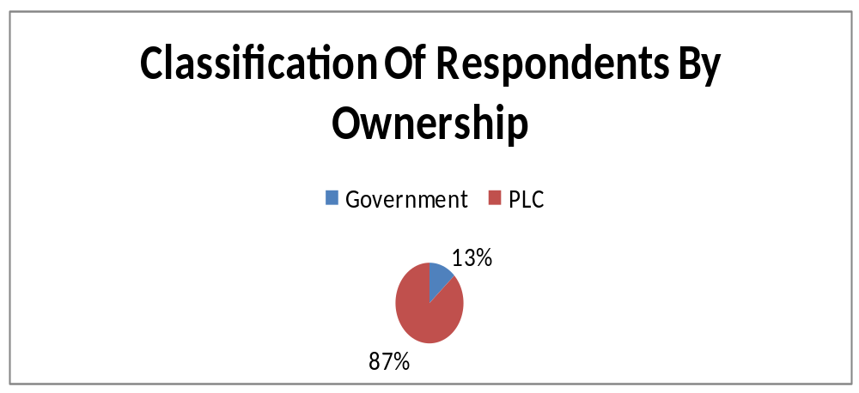

Fig.2 Distributed and Returned Questionnaires by Guna Customers.

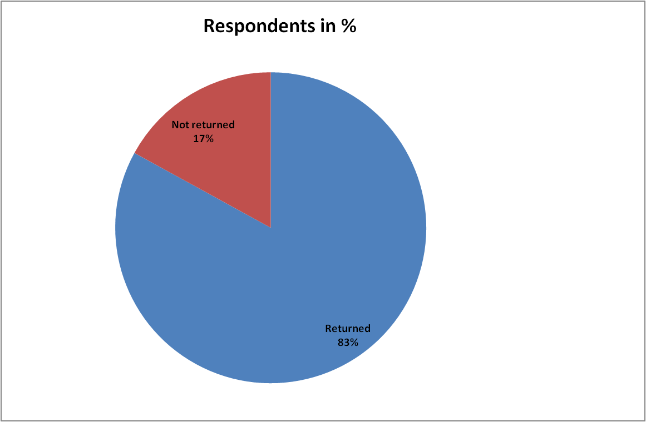

Table 1 Customers' opinion about the price of construction materials of Guna Trading relation to competitors.

Alternative given | Respondents
Alternative given | Number | Percent
Cheap | - | -
Fair | - | 87
Expensive | - | 13
Very Expensive | - | -
Unfair | - | -

According to the customer's opinion regarding Guna's price of construction materials, it is obvious that the price is fair relative to competitors who offer similar materials.

Table 2: Percentage of sampled customer's opinion about technical performance of
salespeople.
Alternative given | Respondents
Alternative given | Number | Percent
Excellent | 2 | 13%
Very Good | 9 | 60%
Good | 4 | 27%
Bad | 0 | 0
Total | 15 | 100%
From the opinion of the customers 60% said the technical performance of sales people is very good. And 13% said excellent and 27% said Good. In addition to this no one says their technical performance is bad from this opinions one understand Guna's sales persons technical performance is Very good.
Customer's opinion on distribution of construction materials from Guna trading
Guna distributes its product to the customers only on the companies shop or branches otherwise the products can't be distributed by using intermediaries. About the convenience of locations of the shops of Guna 73% of respondents said the places of distribution are convenient to them. On the other hand the rest 37% of the respondents said it is not convenient to them. Generally we can conclude that the shops of Guna are convenient to customers. In addition the company didn't give any kind of transportation service to delivers the materials.
Customers' choice of distribution according to their rank order
According to the rank order made by sampled customers 27% of the respondents ranked first the door to door delivery service of the company 20% of the respondents ranked first buying directly from the company and 20% need the assignment of individual customers for a particular geographic area. The slice difference between the ranks helps us to conclude that customers need to have a door to door delivery of products.
Customers preference from the characteristics of Guna.
There are different characteristics of Guna that could be appreciated and preferred by its customers. On this questionnaire there are only six characteristics that customers are asked to rank. The rank orders set by customers are given on the following table.
Table 3. Rank of Guna's characteristics by the sampled customers.
Rank | Alternative given | Respondents
Rank | Alternative given | Number | Percent
1st | Quality Products | 9 | 60%
2nd | Attractive Sales Peoples | 6 | 40%
3rd | Reliable Delivery | 3 | 20%
4th | Convenient Location | 3 | 20%
5th | Technical Assistance | 3 | 20%
6th | Periodical Price Adjustment | 3 | 20%

According to the respondents 60% of them ranks first Guna's quality product. 40% of the sample respondents rand 2nd the Attractiveness of salespeople, 20% made Reliable delivery their 3rd preference again another 20% made its location as 4th preference. In addition to this both technical assistance and periodical price adjustment gets 5th and 6th rank respectively by 20% of the respondents. Quality is preferred by large number of its customers as best characteristic of the company.
Customer's opinion about price of construction materials of Guna relative to its quality.
Price relative to quality means when the amount of money the customer pays for a given product compared the quality of the produce needed by customers. According to the customer's opinion only one respondent said it is not fair in relative to its quality to this respondent is a small business owner this shows that the price of the company in relative to required quality is fair for those who are focuses on quality.

Table 4 Opinion of customers about fairness of price relative to its product quality
Alternative given | Respondents
Alternative given | Number | Percent
Yes | 14 | 93
No | 1 | 7
Total | 15 | 100

Customers' opinion on the assignment of special sales people for each construction material.
According to the answer from the respondents 73% of them don't want to have special salesperson for each product, but 27% of the respondents need special salespeople. Based on this data large number of the company's customers doesn't need the assignment of special sales people.

Table 5. Opinion of customers' for the need to special sales people.
Alternative given | Respondents
Alternative given | Number | Percent
Yes | 11 | 73
No | 4 | 27
Total | 15 | 100

3.2.1.1 Customers measurement level of agreement about the company.
To analyze and measure the level of agreement regarding different characteristics of Guna trading the questionnaire has been offered different questions and the measurement and analysis will present in words and using charts as follows:-
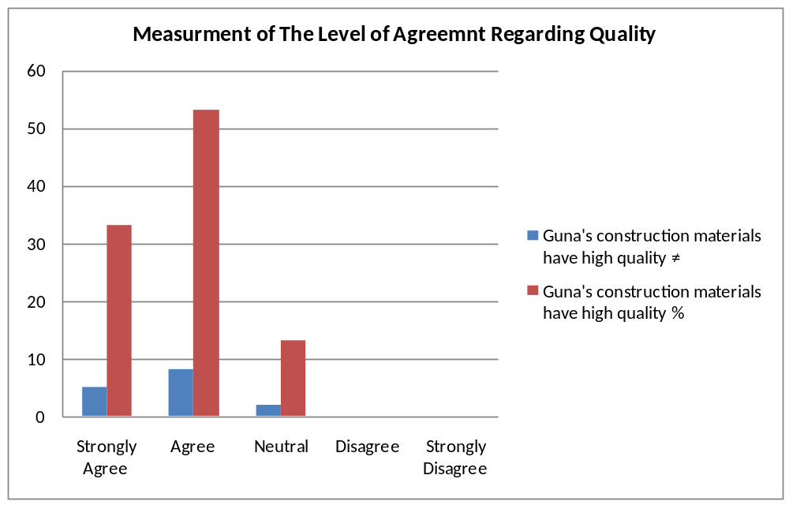
Fig. 3
When we measure the agreement level of the quality product of the company, 5 customers (33%) are strongly agreed that Guna's products have high quality. 8 customers (53%) are agreed by the high quality of the products of the company. 2 customer (13%) are neutral. But no one of the customer is disagree and strongly disagree by the quality of Guna's products.
Totally 86% of the customers are strongly agree and agree by high quality of Guna's product. This shows that, Guna offers high quality product for customers.

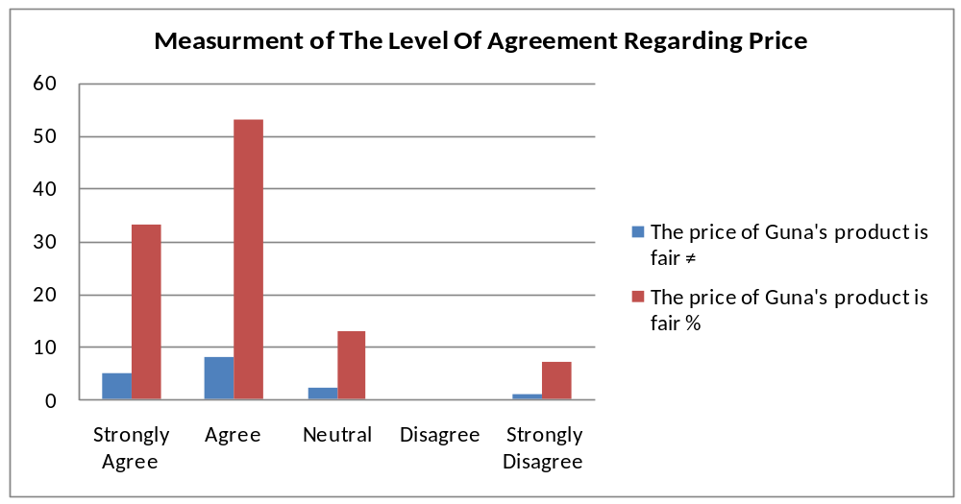
Fig .4
Concerning price, similar to quality, 5 customers (33%) are strongly agreed that price of Guna's products is fair 8 customers (53%) are agreed on the fairness of price of Guna product and 2 customers (13%) are neutral about fairness of price. There is no customer who disagree or strongly disagree regarding the fairness of price of Guna's product. So, it shows that almost 86% of the customers believed that the price is fair.

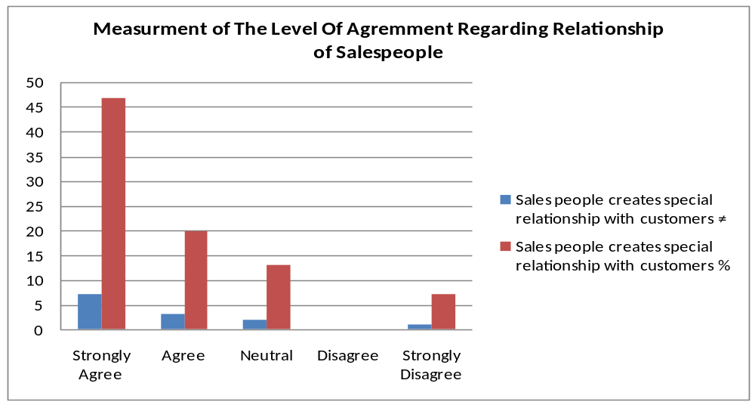
Fig. 5
Regarding the presence of special relationship of sales people with those of customers, from the selected customer , 7 customers (47%) of the sample are strongly agree on the presence of special relationship by the sales people. 3 customers (20%) are agreed about the special relationship of sales people with them. And 2 customers (13%) are neutral about the special relationship of salespeople with them. No customer disagree by the presence of special relationship of sales people disagree by the presence of special relationship of sales people disagree by the presence of special relationship of sales people disagree by the presence of special relationship of sales people with their customers. But 1 customer (7%) strongly disagrees about the presence of special relationship of sales people with customers.
Even if there is one customer who is strongly disagree about the presence of special relationship of sales people. It is not significant to conclude that there is no coaching in Guna. Rather 10 customers (67%) indicate us there is coaching or (special relationship) of sales people with their customers.
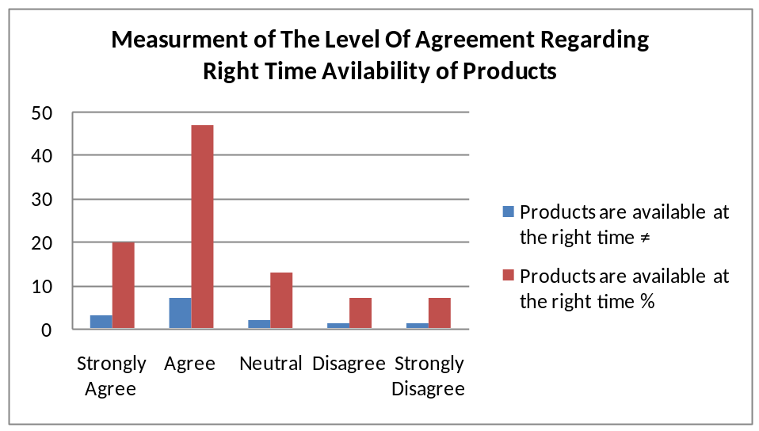
Fig. 6
There is a question to measure their level of agreement in relation to the availability of products at the right time. According to their response, 3 customers (20%) are strongly agreed about the availability of products at right time. and 7 customers (47%) of them are agree by the availability of products at the right time. 2 customers (13%) of the samples are disagree and strongly disagree on the availability of product at the right time. 2 customers (14%) of them are neutral of the availability of products at the right time.
It show that the company deliver the products to its customers at right time.
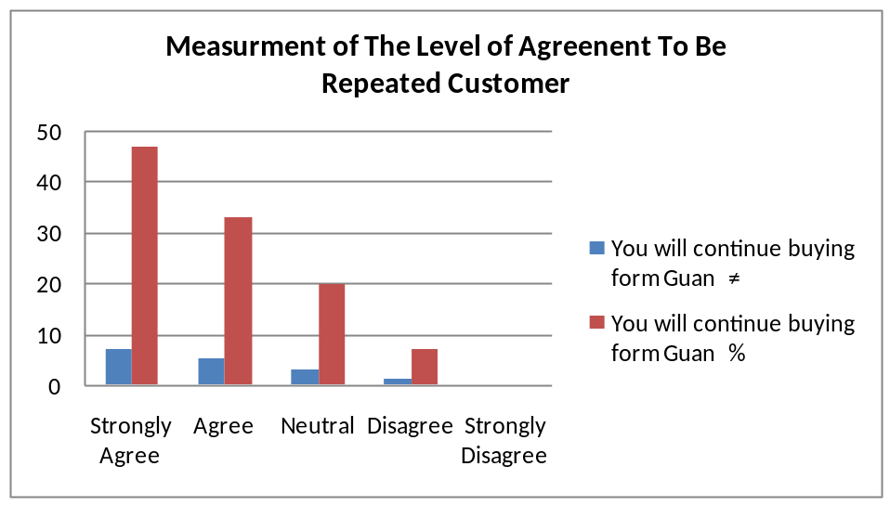
Fig. 7
To measure their intention to come again or to be repeated customer of the company, the questionnaire offers a request whether they are agree to come again or not. Based on their answer, 7 customers (47%) of the samples are strongly agree to come again 5 customers (33 %) are agree to continue purchasing products from Guna. 2 customers (13%) are neutral about their continuation of purchasing from the company. 1 customer (7%) disagree and non of them is strongly disagree to continuous customer of Guna.
The above information indicates that 12 customers (80%) will be repeat customer or loyal to the company.
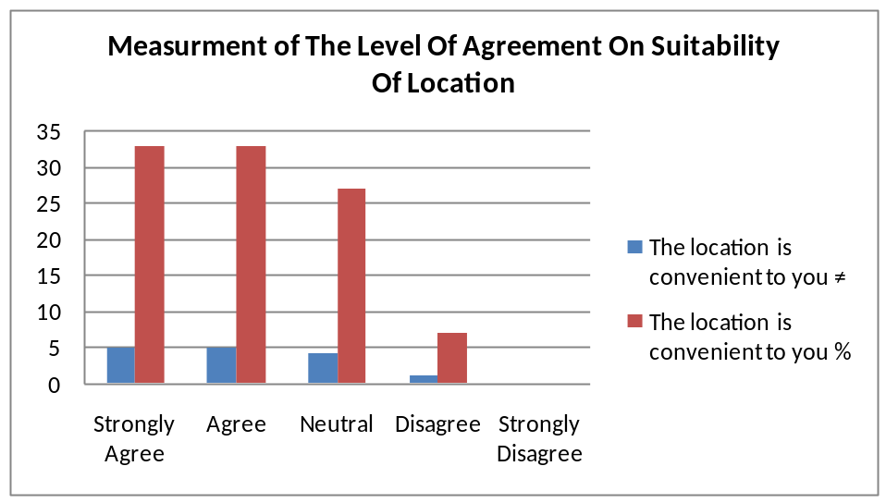
Fig. 8
In the issue of suitability of location to their shop, 5 customers (33 %) are strongly agree on the convenience of location. The same number of customers also agreed on it. 3 customers (20%) of customers are neutral on this issue. 1 customer (7%) disagree on the suitability of location. But no one customer is strongly disagree on the convenience of location of the company to them.

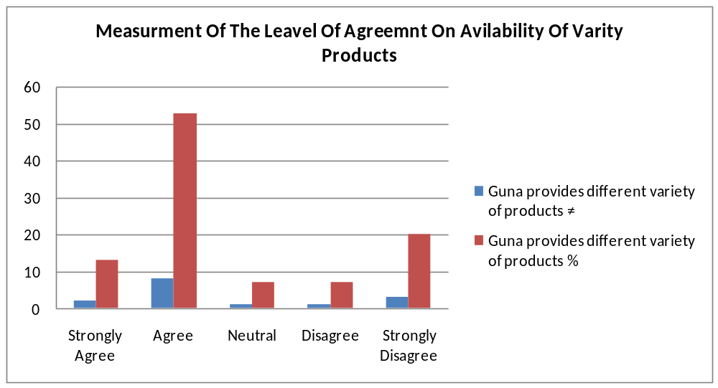
Fig. 9
Concerning the offering of variety of products by the company , 2 customers (13%) are strongly agree and 8 customers (53%) of them are agree on the offering of variety of products by the company, 1 customer (7%) is neutral and similarly 1 customer (7%) of the same disagree on the presence of variety of products. And 3 customers (20%) are strongly disagree by Guan provides variety of products.
Relative to other characteristics of Guna more customers are disagree on Guans offer of various products. But still 10 customers (66%) of them agree and strongly agree on these characteristics so we can say that it offers variety of products to customers.

3.3.1.2 Customers impression about Guan Trading House PLC comparing with its
competitors.
Generally Guna has good image in the mind of customers because of providing reliable quality of product. Right time delivery its location skilled sales people on the other hand. Its competitors have good impression in the mind of customers on their quantity discount and frequent price adjustment.
3.2.2. Interview analysis for the marketing department
INTERVEW DISCUSSION
- Do the company have recorded data about its potential and current customer?
The company has a data base regarding the current customers but there is no culture of recording prospects or potential customers. According to the data base of customers that the company records, it add the customer record will present below.
Customers List
- Amhara Regional State Housing Dev't
- Oromia Regional Housing Dev't
- Sur Construction Private Limited Company
- Kality Construction Company
- Defense Construction
- Kengenam Construction
- Norilo Lalibela
- T/Berhan Ambaye Construction Company
- Yotek Construction Company
- Red Sea Construction Company
- Gluele Kifle Ketema /Subcity
- Eni Construction Company
- Blue Nile
- CGC
- Yeka Kifleketema /Sub city
- Nefas Silk Lafto Kifleketema
- Gift Real Estate Developers
- Flint Stone
- DMC Construction
- Tibeb Construction
- Ethiopian Road Authority
- Ato Tesfaye Nenji
- Ato Teka
- Country Club
- Ato Neguse G/Kirstos
- Woinu Curtail
- Kaliti Construcion
- Addis Engineering
- Hormat Engineering
- IBC
- Nyala Furniture
- Ato Daniel Asefa
- Taytu Hotel
- Medroc Construction
Can you show us the company's organizational structure of marketing department?
- Does the company gives training to sales people after hiring before they sent to the field?
Training is not given to sales people. The company believes that it heir's qualified sales people who have knowledge about selling. Even if there is no a formal training there is what we call on job training that will be given to the new sales person for a period of six months in the help of the work colleagues. There is the so called succession plan. According to this plan each managers and division managers will expect to make efficient every work colleagues under them. So by using this plan, sales people will give informal training. Rather, there is no organized, coordinated and purposeful training given to them before sent to the field.

- What about for previous sales people?
There is the promotional training that will give from the company's customers and chamber of commerce according to the need of the company. There is the so called training need assessment questionnaire distributed within a certain period of time to each worker and for each supervisor to know the need of training. Based on the questionnaires collected from each worker training will be given to previous salespeople of the company.

*Sample of the training need assessment format is found at the back of this page

Why the company give training to the previous salespeople? (Purpose)
The major objectives of the company to give training are:-
- To upgrade the knowledge of salespeople
- To make them to evaluate themselves( their achievements and weakness)
- To motivate the salespeople to do more

How do the company motivate salespeople?
One of the motivation tools is "compensation" when the company get profit as the whole workers get, the sales people also given the bonus. But as recent trail of the company, the compensation is given according to the workers efficiency on their work. The performance appraisal was tried to do objectively based on the workers themselves plan to work. After the performance appraisal of the salespeople the compensation decided will be classified as follows:-

Grade Amount of Compensation
A. 2 months of salary
B. 1 1/2 months of salary
C. 1 month of salary
D. Not given, rather they may be punished and the punishment may be to be fire.

-How does the company decide to give compensation to the sales people?
The company gives compensation when it is profitable.
-For what purpose the company use evaluation of sales people?
The company evaluate the sales people for the following purpose:-
- To appreciate the performance of sales force
- To upgrade the sales people
- To fit them with the work by reshuffling. This means the company will know about the capacities interest of workers with parallel to current responsibility and the manager understands that the current responsibility of the sales force may be under or below their capacity through evaluation. Bases on the salespeople responsibility that fits with their capacity and interest.
- Do the company have sales territory?
The sales people of the company don't have specific geographic area to serve customers. Rather all of the salespeople act in group for the company's "Corporate customers" but for individual customers the salespeople act randomly.
-Who are your customers?
The company's customers are organizational customers. 80% of customers constitute organizational customers and the rest 20% are individual customers of the company. In addition the company is more concerned about organizational customers.
- What is the knowledge's expected from the sales force?
Technical knowledge is more important because, construction materials more of need technical skill. But when training is given the company also emphasize on sociability of sales people in addition to technical skills.

- How to manage your accounts?
The company will try to manage the accounts according to their behaviour. Most of the company's customer focuses on quality product. They don't worry about the price. So to manage the accounts, the company focus on quality product and make the customers to be reliable on it. And it is credible on almost all of the organizational customers. Because

- It is an institution not private shop.
- Major and big reason is the construction materials are highly inspected.

Before the importing of the materials the company ask the customers quality specification and send it abroad to import the materials, the company has its own professionals to inspect the materials quality certificate, if offers both certificates (that comes from abroad and the times some customers inspect again before they purchase the product by using their own professionals .Example Ethiopian Defence force. So the company's customers are reliable on the quality of the company's product and the company manages its accounts by fulfilling their needs based on their behaviour.
How to organize the sales people/?
The company organize the sales people on the following principles of organization
- Product specialization:- the company's marketing department is classified in to two groups
- Industry products
- Agricultural products
Within the industry products the sales people are specialize on chemicals, distaffs, cement, timber etc. and agricultural division sales also specialized in specific agricultural products.
- Telemarketing: - telemarketing also used in the company's marketing activity especially for the agricultural products division. Every marketing activities of the company is carried through fax, e-mail, and telephone. But in the industrial products, there is no need of extensive use of telemarketing. Because customers want personal communication with sales force.
- National account:- the company have also organize the sales people on national account. The company key accounts are corporate customers. But the company has not independent sales agent.
- How the company forecast and budget its sales?
The company forecast sales based on the country's situation
-Based on the government plan
-Based on the information offered by customers to sales people
- How does the company design its channel system?
-The company has not extensive channel member.
- How many channel levels the company have?
- The company's channel level is direct. Because, the company's major customers need is face to face communication. Besides the products have technical.
- What do the company consider before setting the price?
-The company mainly consider its marketing objectives before setting the price. And the main objective of the company is customer satisfaction.

- How do the company set price?
  - The company use cost plus pricing method
- When the company adjust price?
  - To adjust the price of materials, the company need to take a long time. It a tries to adjust the price when the demand for the construction materials become decrease.
CHAPTER FOUR
CONCLUSION AND RECOMMENDATION
4.1 CONCLUSION
From the findings of the study, the following major conclusions are made.
- The price of Guna's imported construction materials are fair in relative to its quality most of its customers focuses on the quality of the products they require; because of this they said the price is fair.
- Sales people technical performance is very good so that the company has good relationship with its customer. Sales people can express the quality and other technical characters of the products.
- The company has sale its products only at its shop. It has no delivery service even if it has this problem the warehouses are not out of the city and because of this they are convenient to customers.
- The company delivers quality products with different varieties. So that customers can get right products at the right time.
- The customers of Guna are organizational buyers because of this they buy in large quantity and they need the sales people to be attractive and sociable.
- Guna doesn't make price adjustment frequently but the competitors have frequent price adjustment and also give quantity discount. This opportunity is not given by the company.
- The company is not given fast decision making for the interest of customers.
- The company has the data base of current customers
- There is a very broad marketing organizational hierarchy.

- The company don't give training for new salespeople. Rather it gives training for previous salespeople.
- The objectives of the company for giving training for previous salespeople are to upgrade their knowledge, to evaluate themselves and to motivate them to do more.
- The company tried to motivate the sale force through promotion and compensation when it gets profit.
- The company has not sales territory.
- The company evaluate the salespeople, to appreciate the performance of sales force, to upgrade the sales people, to fit them with the right duty with right capacity.
- To manage the accounts, the company asses the behaviour of its customers to design services and product according to their behaviour.
- The company organize its salespeople by product specialization, telemarketing and national account. But it has not independent sales agents.
- The company is using personal selling.
- The company forecast and budget sales based on the country's situation, gov't plan, information offered by salespeople.
- The company has not long channel, rather it distribute the product directly to customers.
- The marketing objective of the company is customer satisfaction. So when the company sets price it consider first this objective.
- The department responsible to set prices use cost plus pricing technique, which is set by adding a certain mark up to the costs of importing and distributing the goods.

4.2 REDOMMENDATION
After assessing the company's the company's performance regarding pricing, sales and distribution system form its own marketing department and the customer's opinion regarding the above issues, the study will offer some recommendations to the company.

- The company should try to maintain the delivery of quality products and take great focuses on it. Because it is the major characteristic that creates a better image in the mind of customer.
- Similarly the technical performance of its salespeople is very good. If the company has to continue giving frequent training to cop up their performance in addition to this salespeople have to creates more relationship with customers.
- Boosting the wealth of the company is one of Guna's objectives. In order to meet this objective individual customers have contribution. However the company doesn't give attention to them. Because they are important to increase sale the company have to give attention and treat them better than earlier.
- The company's bureaucratic management system creates a difficulty on making price adjustment. On the other hand competitors can make actual discount and attract customers by doing so. To continue become better than its competitors, the company should adapt fast decision making and higher flexibility.
- To win customer interest on getting quantity discount, it is better if Guna would permit quantity discount because most of its customers are organizational customers. They buy in large quantity and also they could get quantity discount from other competitors.
- The company recognize the need of product delivery to customers and it is trying to get ready to give this service. It is a very good idea so that it has to be done within a short period of time.
- The company should give training to new salespeople to familiarize the salespeople with the company's product, services and operating procedures. Because training is important to reduce turnover improve relations to have a better moral and to increase sales.
- A sale planning is made easier when managers have good data on where potential customers are located. Therefore, the company should have record on potential customers.
- The most powerful motivator for salespeople is a well designed compensation package. Thus it s a key task for sales managers to come up with an effective mix of salary, bonuses, commissions, expenses and benefit without putting the firms profitability in jeopardy. Therefore the company should compensate the sales people without considering the presence of profit.
- The company should use independent sales agent to perform the selling function within specified geographic area.
- The company should use the right sales management process.

Annex I

Addis Ababa University College of commerce
Department of Marketing Management
Questionnaire to assess Guna Trading House PLC Pricing, Sales, and Distribution system on construction materials
The questionnaire is prepared to investigate the company's pricing, sales and distribution system.
The respondents are selected based on their frequency of purchase from the company.
Instruction
The questionnaire contains three forms of questions. We ask kindly to read each statement and put a " ü " mark on the appropriate position
We request you kindly to fill the questionnaire honestly

- Read each statement and put a "ü " mark on the appropriate scale position
- Do you buy construction materials from Guna trading?
□ Yes
□ No
- How do you see the price of construction materials relative to competitors?
□ Cheap
□ Faire
□ Expensive
□ Very Expensive
□ Unfair
- How do you evaluate the company's sales people technical performance?
□ Excellent
□ Very good
□ Good
□ Bad
- Is the distribution convenient to you?
□ Yes
□ No
- If the distribution is not convenient to you, rank your choice of distribution?
□ An individual sales person should be assign for particular geographic area
□ Buying directly from the company
□ Getting door to door sell of the company
- Rank your choice of characteristic of Guna which you prefer?
□ Periodical price adjustment
□ Quality products
□ Attractive sales people
□ Technical assistance
□ Reliable delivery
□ Convenient location

- Do you think that the price of construction materials of the company is fair relative to its product quality?
□ Yes □ No

- Is that convenient to you the assignment of special sales people for each construction materials?
□ Yes □ No
- Indicate your impression of Guna Trading House PLC and _______________________________mark a " • " by choosing the line corresponding to your opinion for each pair of descriptor.
Price too low ____ ____ ____ ____ ____ ____ ____ price too high
No price discount ____ ____ ____ ____ ____ ____ ____ price discount
Right time delivery ____ ____ ____ ____ ____ ____ ____ delay on delivery
No quantity discount ____ ____ ____ ____ ____ ____ ____ quantity discount
Frequent price adjustment ____ ____ ____ ____ ____ ____ ____ No frequent price adjustment
Inconvenient location ____ ____ ____ ____ ____ ____ ____ convenient location
Reliable quality ____ ____ ____ ____ ____ ____ ____ Unreliable quality
Unskilled sales people ____ ____ ____ ____ ____ ____ ____ Skilled sales people
Motivated sales people ____ ____ ____ ____ ____ ____ ____ Unmotivated sales people
Un influential sales people ____ ____ ____ ____ ____ ____ ____ Influential sales people
Sociability of salespeople ____ ____ ____ ____ ____ ____ ____ Unfriendliness salespeople
- Read each statements and put a " ü " marks on the appropriate scale positions

Strongly Agree Neutral Disagree Strongly
Agree Disagree
1. Guna's construction materials have ______ _____ _____ _____ _____
high quality
2. The price of Guna's product is fair ______ _____ _____ _____ _____
3. Sales people creates special relationship ______ _____ _____ _____ _____
with customers
4. Products are available at the right time _____ _____ _____ _____ _____
5. You will continue buying from Guna _____ _____ _____ _____ _____
6. The location is convenient to you _____ _____ _____ _____ _____
7. Guna provides different variety of products _____ _____ _____ _____ _____
Thanks for your kind cooperation.

Annex II
Interview Questions for the Company's Sales Department
- Do you have recorded data about your potential and current customers? And can you offer to us?
- Can you show us the company's organizational structure of marketing department?
- Does the company give training to sales people after hiring before they sent to the field?
  - What about for previous salespeople? If yes, why? No, why not?
- If yes,
- For how long you give training?
- What are the main topics or areas of training?
- How the company do motivates sales people .Through compensation or commission?
- If the sales people are given compensation when do the company compensate them?
- How does the company decided to give compensation to sales people?
- Number of calls
- Reports prepared
- Sales order
- Sales growth
- Number of new accounts
- For what purpose the company use evaluation of sales people?
- For compensation
- To modify selling strategy
- To improve the organization
- Has an individual sales person specific geographic area to serve?
- How do you design this territory?
- Who are your customers?
- Consumer
- organization
- What is the knowledge's expected from the sales force?
- Technical
- Theoretical
- How to manage your accounts?
- Economic buying, concerned on performance and price
- User buying influence ,
- Technical buying influence
- Coatch- special relationship with buying organization.
- How to organize the sales people?
- Specialization
- Telemarketing
- National account - concentrate on few and very important
- Independent sales agent
- How the company forecast and budget sales?
- Depending on the information that gust from sales people.
- Depending on the opinion of executives.
- How does the company design its channel system?
- Analyze consumer needs
- Setting channel objectives
- What are the major needs of your target customers from the channels?
- How do the channel members add value?
- Promotion
- Contract , - finding and communicating
- Matching, - fitting the buyers need
- Negotiation, - reaching an agreement
- How many channel levels the company has?
- Direct
- Indirect
- What do the company consider before setting the price?
- Marketing objectives
- Marketing mix strategy
- Cost
- Organizational consideration, - who will set price in the organization?
- Nature of market, and demand , competition
- How do the company set price?
- Cost based pricing, - adding a standard mark up.
- Competition pricing, - based on competitors price
- Value based pricing, - uses buyers' perception of value
- When the company adjust price?
- Discount, during a stated period of time
- Allowance

Bibliography

Johansson J.K 2000:12
Kotler 1999:7
(Anderson) Vincze, 2000:85
Philip Kotler Principles of Marketing,
'' Still Cundiff Govoni ''Sales Management 5th Edition.
Dauglas J. DALRYMPLE William L.CRON. Sales Management 4th Eition.
Philip Kotler, Gary Armstrong Principle of Marketing 11th edition.
SalesManagement Richard R. Still Edward, W. cunDiff, Norman A.P. Govoni

